**Name:________________________**

**Mathematics: Methods Unit 1**

**Test 3, 2015**

**Trigonometric Functions and Equations, Probability**

**Calculator Free**

**25 marks**

**25 minutes**

**No Calculators Allowed**

**SCaSA Formula Sheet**

**Question 1 [1, 1, 1 = 3 marks]**

Shade in the region described by the following:

A

B

1. A ∩ B

B

C

1. B ∪ C’

A

B

C

1. (A ∪ B) ∩ C

**Question 2 [3 marks]**



From the following Venn Diagram:

Find:

Leave your answer in **FRACTION** form

1. P(A ∪ B)
2. P(A/B)
3. P(A’ ∩ B)

**Question 3 [8 marks]**

State the exact value of each of the following.

a) $\sin{\frac{π}{3}}=$ b) $\sin^{2}{3+\cos^{2}{3=}}$

c) $\cos{\frac{π}{4}=}$ d) $\cos{150°=}$

e) $\sin{\frac{5π}{3}=}$ f) $\cos\left(nπ\right)$ where *n* is an odd integer

g) $\tan{210°}=$ h) $\sin\left(-\frac{π}{6}\right)=$

**Question 4 [2, 3, 3 =8 marks]**

Solve the following trigonometric equations. Show working.

1. $\sin{x=-\frac{\sqrt{3}}{2}}$ in the interval $0≤x≤2π$
2. $2\sin^{2}{x=\frac{1}{2}}$ in the interval $0°≤x≤360°$
3. $\cos{2x=\frac{1}{2}}$ in the interval $0°≤x≤180°$

**Question 5 [3 marks]**

The graph below is of the general equation $y=\cos\left(a(x+b)\right)+c$.

Determine the values of *a*, *b* and *c*.

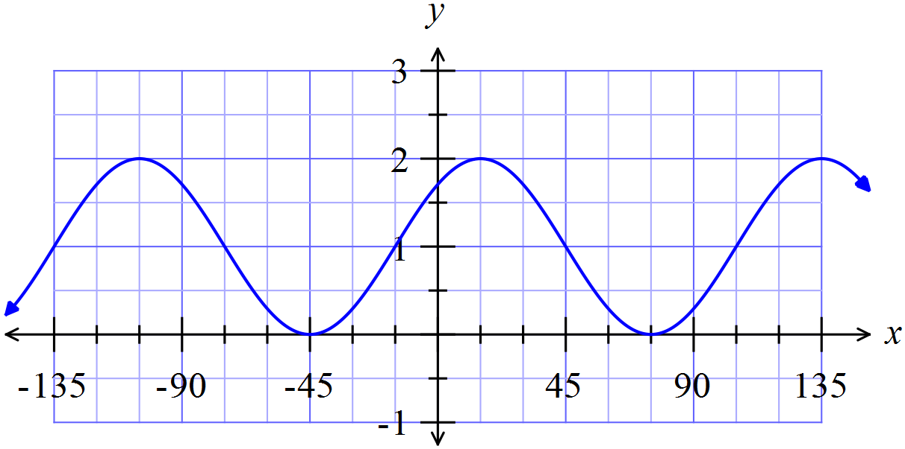

**Name:________________________**

**Mathematics: Methods Unit 1**

**Test 3, 2015**

**Trigonometric Functions and Equations, Probability**

**Calculator Assumed**

**30 marks**

**30 minutes**

**Approved Calculators Allowed**

**A4 Page of Notes**

**SCaSA Formula Sheet**

**Question 6 [3, 4 = 7 marks]**

Amos asked Lara what she would like for lunch and offered her several choices:

In her sandwich she could have jam, peanut paste or chicken.

As a sweet she could have a Mars Bar or a jam donut.

For fruit she could have a banana, an apple or a pear

Lara never has two jam items on the same day, and if she has a Mars Bar she always selects an apple for fruit.

1. Draw a tree diagram showing all possible combinations of lunches for Lara if it is known that she took a sandwich, a sweet and a piece of fruit.
2. Use the tree diagram to determine the following probabilities:
3. she chooses a jam sandwich
4. she has an apple and a Chicken sandwich
5. she chooses a jam donut or an apple
6. she chose a chicken sandwich given that she chose an apple

**Question 7 [2, 2 =4 marks]**

State the period and amplitude for each of the following.

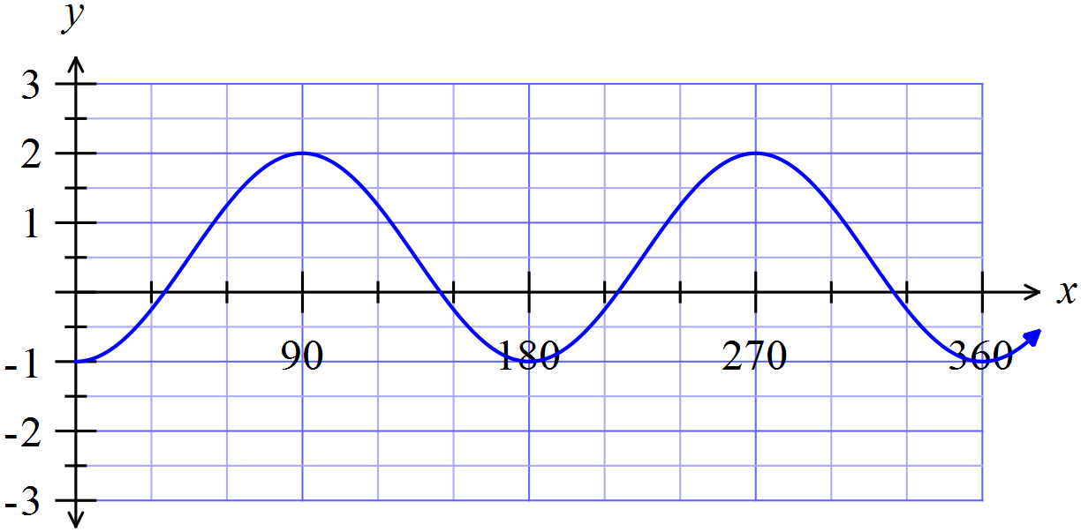





$y=-\tan\left(x+\frac{π}{4}\right)$

**Question 8 [1, 1, 1 =3 marks]**

Given the graph below of a sinusoidal function, determine its:

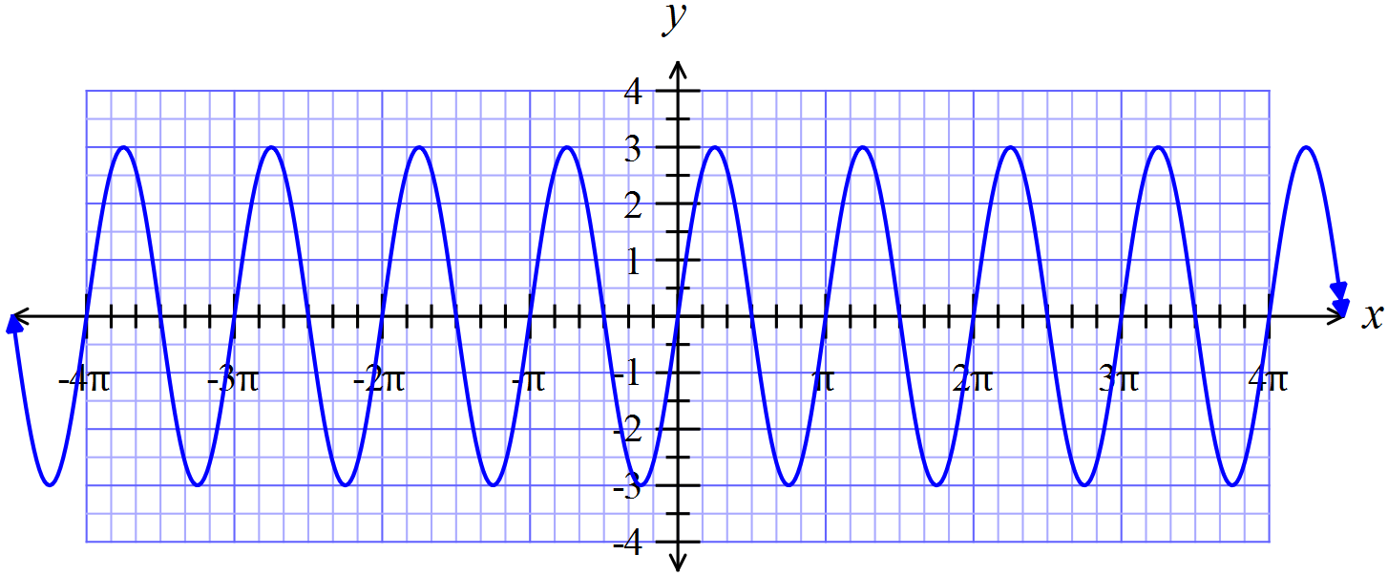

1. amplitude
2. period
3. equation

**Question 9 [2, 1, 2, 2 =7 marks]**

A student travelling to school has to pass through two sets of traffic lights A and B that operate independently of each other. The probabilities that she will be stopped at these lights are $\frac{5}{8}$ and $\frac{7}{10}$ respectively, with corresponding delays of 2 minutes and 3 minutes. Without these delays her journey takes 20 minutes.

1. Complete the tree diagram, entering the appropriate probabilities in the given brackets.

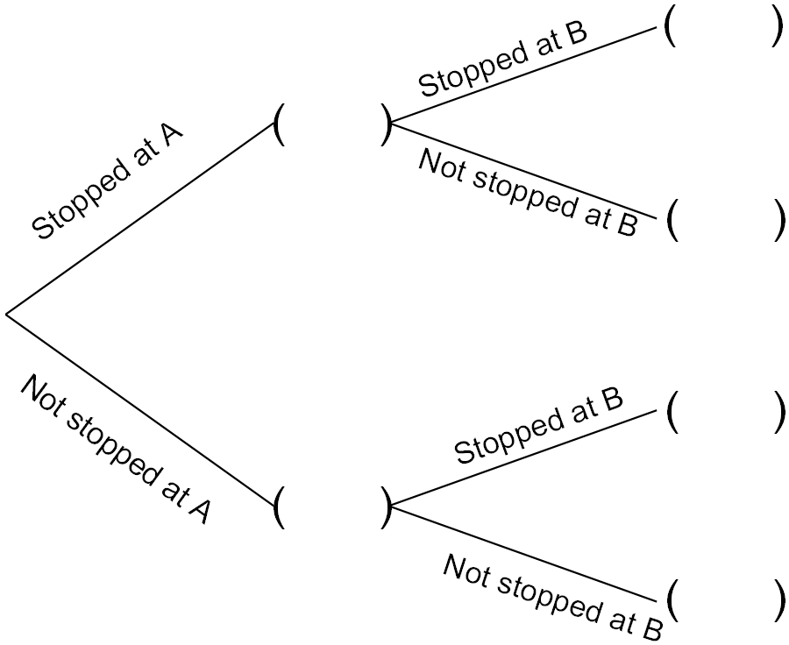

1. Determine the probability that
2. The journey takes no more than 20 minutes.
3. The student encounters just one delay
4. One morning the student has only 22 minutes to reach school on time. Determine the probability that she will be late.

**Question 10 [1, 4 =5 marks]**

If $\sin{A=\frac{4}{5}}$ and $\cos{B=-\frac{7}{25}}$ where $0≤A≤\frac{π}{2}$ and *B* is obtuse, determine exactly:

$\tan{A}$

$\sin\left(A+B\right)$

**Question 11 [4 marks]**

For two events *A* and *B*, P(*A*) = 0.3 and P(*A* ∪ *B*) = 0.6

Determine P(*B*) if events *A* and *B* are independent.